**NEW SITE FEEDBACK 5/1/2023**

1. **TOP BARS**
2. TOP BAR 1 - THINGS TO HAVE

Before user logs in

1. LOGO at the far left as is
2. LOGIN Just after logo on the far right and color should be BIKOPINK
3. REGISTER Just after LOGIN on the right and color should be BIKOBLUE



After user logs in

1. LOGO at the far left as is
2. BALANCE & BONUS Just after Logo on the far right
3. DEPOSIT Just after Balance & Bonus on the right and color should be BIKOPINK

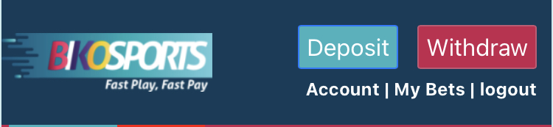

NOTE: Every background bar should be of the same size or lower in height with the LOGO’S background bar. Very important for look and feel.

1. TOP BAR 2 – THINGS TO HAVE
2. SPORTS at the far left as is
3. LIVE Just after SPORTS
4. JACKPOT Just after LIVE
5. SEARCH on the far left
6. MENU Just after Search



1. 8 things to have in MENU. See picture below

* LANGUAGE
* MY BETS
* DEPOSIT
* WITHDRAW
* MY TRANSACTIONS
* DOWNLOAD APP
* HELP
* LOGOUT

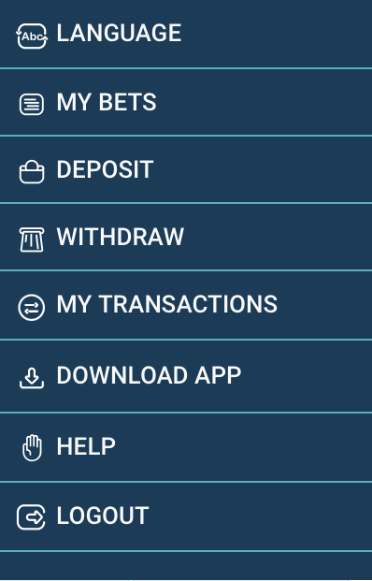

1. BANNERS SPACE

Remove all the dummy banners and remain with only the BONGE LA SITE banner and the ones I’ve attached and let’s make sure they are all of the same size. The glitch happens because of banner sizes variation. See Picture below and attached Video.

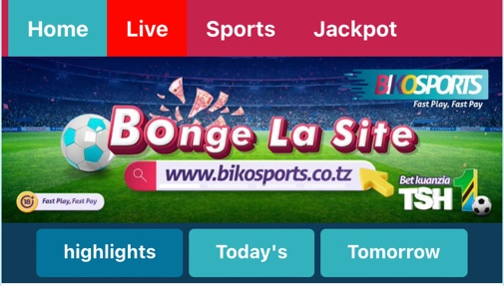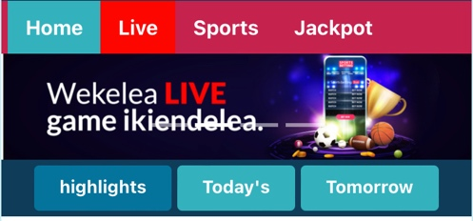

1. HIGHLIGHTS BAR

Remove the boxes and let’s just use an underliner to show where we are HIGHLIGHTS, TODAY’S, TOMORROW.

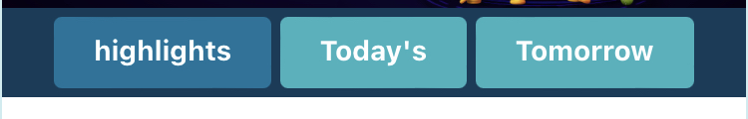

Also

* HIGHLIGHTS should read as MECHI KALI and should be in the middle
* TODAY’S should read as MECHI ZA LEO and should be on the left
* TOMORROW should read MECHI ZIJAZO and should be on the right.

1. **MATCH LISTINGS**
2. THE UNDER ODDS OPTION

This option should be just below the highlights bar and just before any match listings. See Picture below

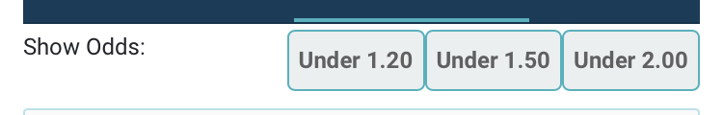

1. In the initial doc we requested to have the most liked betting options which are 3 WAY, DOUBLE CHANCE (DC), OVER/UNDER (OV/UN), and BOTH TEAM TO SCORE (BTS).
2. We also requested the use of signs that is the STAR SIGN to represent MOST LIKED MATCHES, THURNDER SIGN to represent matches with BOOSTED ODDS, LIFE LINE SIGN to represent LIVE MATCHES. “I will attach the ICON’S on WhatsApp as well.
3. LOOK AND FEEL
   * + - * The color used in odds is not within our color palates, you can use the same as for the more markets which is black. See picture below for reference.

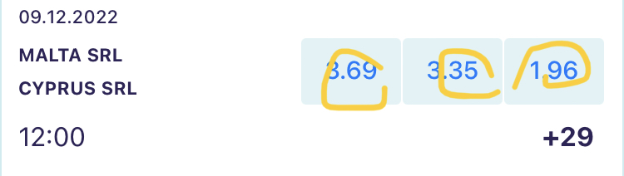

* + - * + Also, the naming of the teams we can stretch to have atleast two instead of just one for example MANCHESTER UNITED F…… instead of MANCHESTER U……. See picture below for reference.

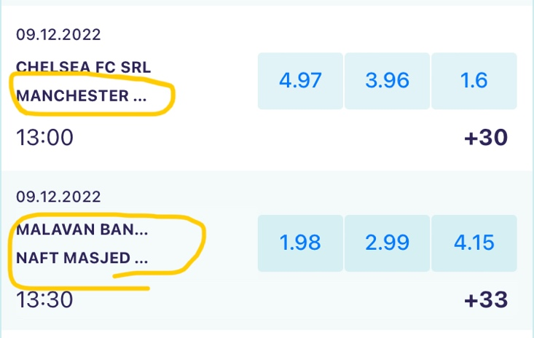

1. **BETSLIP**
2. BETSLIP BOTTOM BAR

Let’s just have 3 key areas here instead of 4. Let’s have **Betslip, Total Odds and Place Bet**. This 3 will help us have a good look and feel. Not one to be too wide and the other to be thin. And also let’s reduce the wideness of the entire betslip bar. Isiwe kubwa sana.

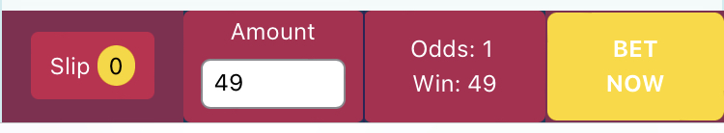

Below is wording to replace;

* SLIP replace with BETSLIP
* ODDS replace with TOTAL ODDS
* BET NOW replace with PLACE BET

1. PLACE BET PAGE

* Add BONUS just after POSSIBLE WINNINGS
* Add (TZS) after every naming for example 10% WITHHOLDING TAS (TZS)
* Change the colors for REMOVE ALL to BIKOPINK
* Repalce BET NOW with PLACE BET and change colore to BIKOBLUE

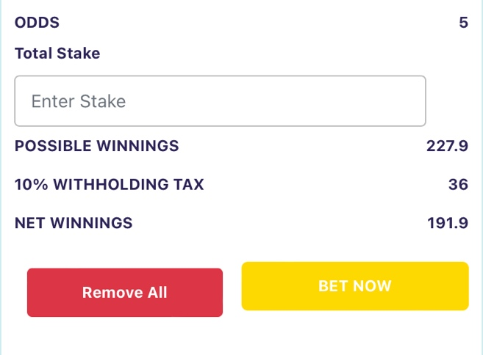

NOTE: Also, the WIN BONUS element of Add one more match to get a X% as bonus is missing. See picture below

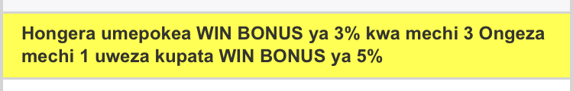

1. **DEPOSIT**
2. Change the line “Top Up Now” to “DEPOSIT”. See picture below

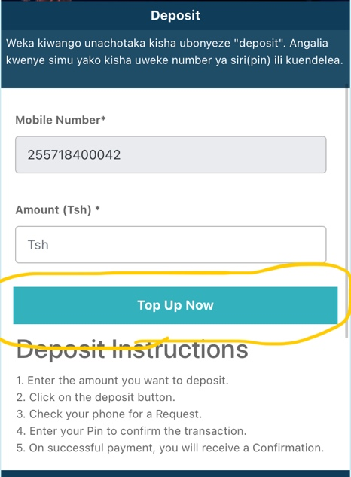

1. As I select to insert a number or amount, don’t pull it up just bring the keyboard to insert the number. Because when you pull it up it troubles me to again bring the page back to its normal size and I don’t know how. See Picture for reference

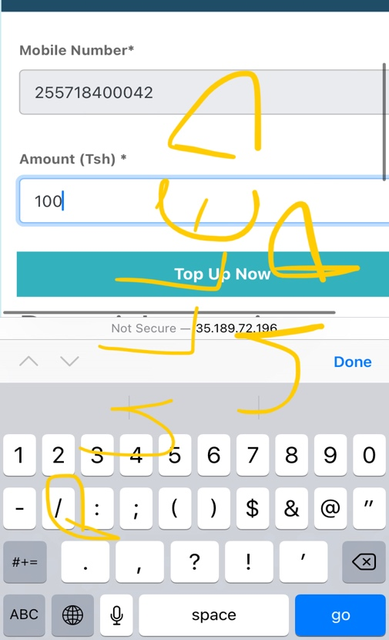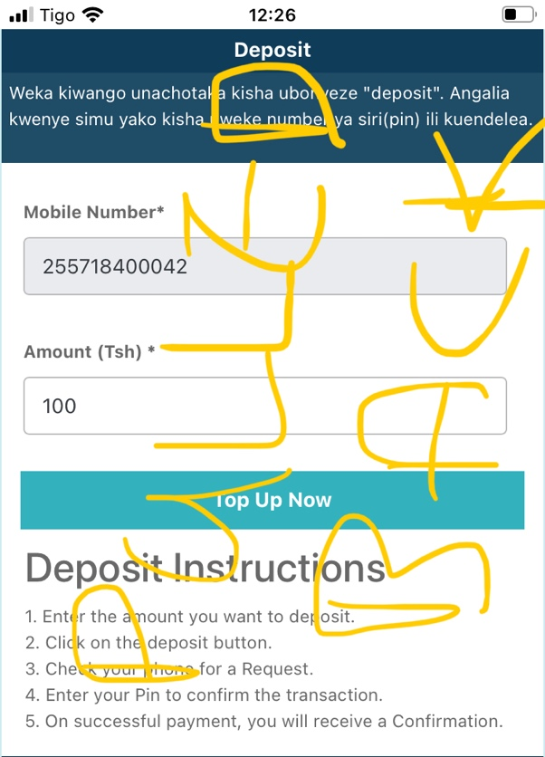

1. Add a HOW TO DEPOSIT MANUALLY element for users who would wish to deposit manually on phone. And place their respective logos on top of each MNO. See below picture as an example

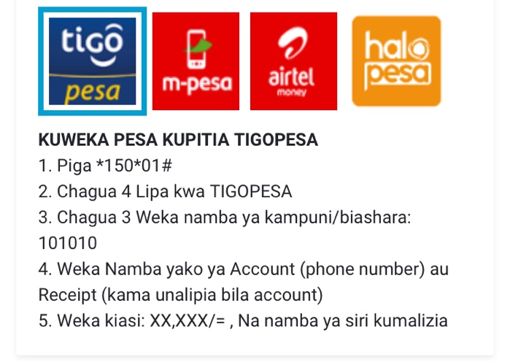  
  
And below is updated HOW TO DEPOSIT ON PHONE.

**KUWEKA PESA KUPITIA TIGOPESA**

1. Piga *150*01#
2. Chagua 4 Lipa kwa TIGOPESA
3. Chagua 3 Weka namba ya kampuni/biashara: 101010
4. Weka Namba yako ya Account (phone number) au Receipt (kama unalipia bila account)
5. Weka kiasi: XX,XXX/= , Na namba ya siri kumalizia

**KUWEKA PESA KUPITIA M-PESA**

1. Piga *150*00#
2. Chagua 4 Lipa kwa M-PESA
3. Chagua 4 Weka namba ya kampuni/biashara: 101010
4. Weka Namba yako ya Account (phone number) au Receipt (kama unalipia bila account)
5. Weka kiasi: XX,XXX/= , Na namba ya siri kumalizia

**KUWEKA PESA KUPITIA AIRTEL MONEY**

1. Piga *150*60#
2. Chagua 5 Lipa bili
3. Chagua 4 Weka namba ya kampuni/biashara: 101010
4. Weka Namba yako ya Account (phone number) au Receipt (kama unalipia bila account)
5. Weka kiasi: XX,XXX/= , Na namba ya siri kumalizia

**KUWEKA PESA KUPITIA HALOPESA**

1. Piga *150*88#
2. Chagua 4 Lipa bili
3. Chagua 3 Ingiza namba ya kampuni/biashara: 101010
4. Weka Namba yako ya Account (phone number) au Receipt (kama unalipia bila account)
5. Weka kiasi: XX,XXX/= , Na namba ya siri alafu bonyeza moja kuthibitisha.
6. **EXTRAS**
7. BET SHARING OPTION

We also had requested to have a bet sharing option as one of the elements so one can share their bets with friends.

1. REBET OPTION

We don’t see the REBET option as we requested from our initial elements document. This being one of the key elements we requested.

1. MATCH STATISTICS  
   We also need to see an element of match statistics for our punters so we help them become more knowledgeable about a match even before placing a bet.
2. THE BOTTOM PAGE

This is the information page such as social medias, trademarking, licencee, Office Address, under age and more.

What we need is to also see pictures and logos and icons to make it interesting.

Below pictures on the left is what we have, and on the middle and right is the look and feel we need to have.

